*Florida International University*

*School of Computing and Information Sciences*

CIS 4911 - Senior Capstone Project

Software Engineering Focus

Feature Document

User Story # 595

**Team Member:**

Garrett Lemieux

**Product Owner(s)**:

Francisco Ortega

**Mentor(s)**:

Francisco Ortega

**Instructor**: Masoud Sadjadi

# 

# **User Story**

* As a User I would like to be able to to have the same functionality as the multi touch device when drawing lines with leap motion in order to allow for diverse images to be created with leap motion.

## **Use Case**

User want to change the size of line or color of line being drawn with leap motion.

* Details:
* Actor:
  + User
* Pre-conditions:
  + TouchPoint app is running.
  + Leap motion drawing is enabled
* Description:
  + Use case begins when User has decided to change the size of the line or color of the line to be drawn when using leap motion.
  + User can press ‘z’ to decrease size of drawn line or ‘x’ to increase the size of the drawn line.
  + User can press ‘q’ or ‘w’ to cycle through colors or ‘r’ to change color of line to random colors.
  + Use case ends once the user finishes painting a line and the line is a different size or different color.
* Post-conditions:
  + The size of the line drawn by user has changed depending on chosen key or color of line has changed depending on chosen key.
* Alternative Courses of Action:
  + User can decrease the size of line painted by pressing ‘z’ key.
  + User can increase the size of line painted by pressing ‘x’ key.
  + User can cycle forward through possible color of lines by pressing ‘w’ key.
  + User can cycle forward through possible color of lines by pressing ‘q’ key.
  + User can change color of line to a random color by pressing ‘r’ key.
* Decision Support:
  + Frequency: High , User will need to vary his or her lines and color of lines to create unique paintings.
  + Criticality: High , Allows Users to depict different designs with varied sized and colored lines.
  + Risk: Low , Had the varied line function and varied color functions created for multitouch need to make it work with leap motion implementation.
* Constraints:
* Usability:
  + Need to be able to read user guide and follow instructions
* Reliability
  + High
* Performance
  + Performance High , low failure
* Supportability
  + Multi-touch Screen (ACER)
  + Leap Motion Device
* Modification History:
  + Owner: Garrett Lemieux
  + Initiation Date 02/15/2015
  + Date last Modified: 02/28/2015

## **Sequence Diagram**

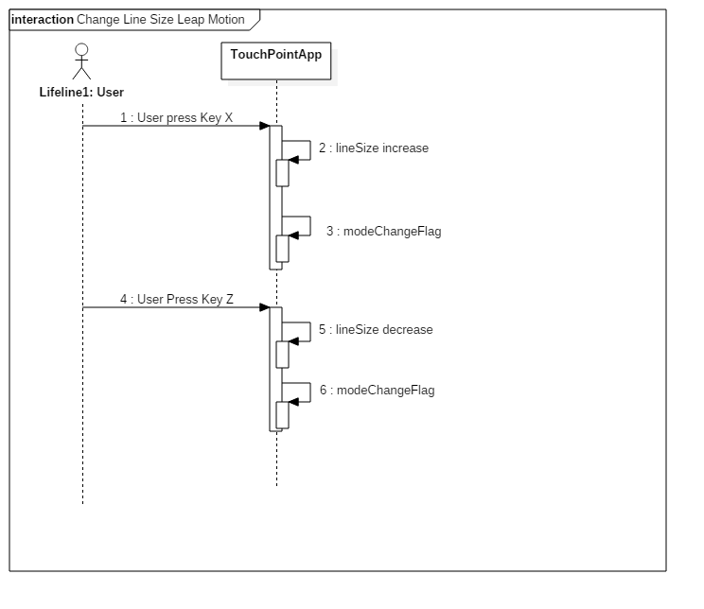

## 

## **Class Diagram**

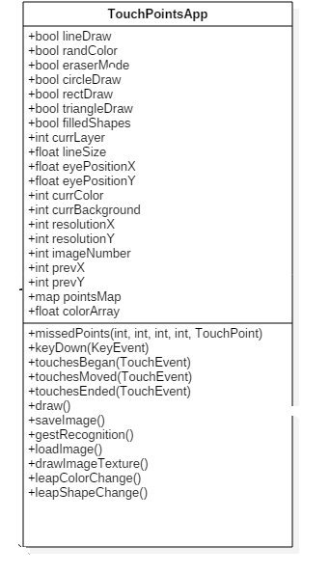

## **Unit Test**

* Sunny Day Test:
  + User wants to increase line size by one degree.
    - He or she presses ‘x’ key once so line increases by one degree
  + User wants to increase line size by three degrees
    - He or she presses ‘x’ key the three consecutive times before drawing to get increase.
  + User wants to decrease line size by one degree.
    - He or she presses ‘z’ key once so line increases by one degree
  + User wants to decrease line size by three degrees
    - He or she presses ‘z’ key the three consecutive times before drawing to get increase.
  + User wants to change color to next possible color.
    - He or she presses ‘w’ key once so color changes to next specified color by one position.
  + User wants to change color of line to color that is three positions away.
    - He or she presses ‘w’ key the number of times the desired color is away from current color
  + User wants to change color to last color drawn.
    - He or she presses ‘q’ key once so color changes to next specified color by one position.
  + User wants to change color of line to previous color that is three positions away.
    - He or she presses ‘q’ key the number of times the desired color is away from current color
  + User wants to change random color on.
    - He or she presses ‘r’ key when random color mode is off.
  + User wants to change random color off.
    - He or she presses ‘r’ key when random color mode is on.
* Rainy Day Test:
  + User presses ‘x’ key repetitively to increase line more than system allows .
    - He or she presses ‘x’ 20 times.
  + User presses ‘z’ key repetitively to decrease line more than system allows .
    - He or she presses ‘z’ 20 times.
  + User presses ‘w’ key repetitively to change color line in forward direction more than system allows .
    - He or she presses ‘w’ 20 times.
  + User presses ‘g’ key repetitively to change color line in backward direction more than system allows .
    - He or she presses ‘g’ 20 times.
  + User press ‘r’ key repetitively to change random on and off
    - He or she presses ‘r’ 20 times
  + User presses two different keys at the same time

## **Integration Testing**

* The ability to use change of line size function works in TouchPointsApp.cpp when
  + When ‘x’ key is pressed the line size is changed for both multi touch and leap motion lines that are drawn.
  + When ‘z’ key is pressed the line size is changed for both multi touch and leap motion lines that are drawn.
* The ability to use change of color function works in TouchPointsApp.cpp when
  + ‘w’ key is pressed the color cycles forward through list of possible colors and changes current color for both multi touch and leap motion lines that are drawn.
  + ‘q’ key is pressed the color cycles backwards through list of possible colors and changes current color for both multi touch and leap motion lines that are drawn.
  + ‘r’ key is pressed the color of line is changed to random colors for both multi touch and leap motion lines that are drawn.

## **User Guide**

* Once a user has decided to change the size of his or her line being drawn with leap motion device user can decrease size of line by pressing ‘z’ key and increase size of line by pressing ‘x’.
* Once a user has decided to change the color of his or her line being drawn with leap motion device user can cycle through colors in a forward direction by pressing ‘w’ key and cycle backwards through colors by pressing ‘q’.
* Once a user has decided to change the color of his or her line to be a random color he or she must press ‘r’ key.